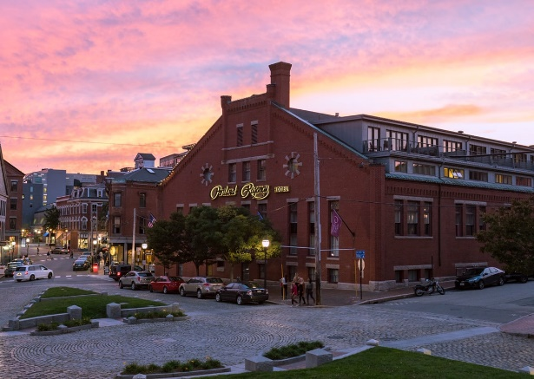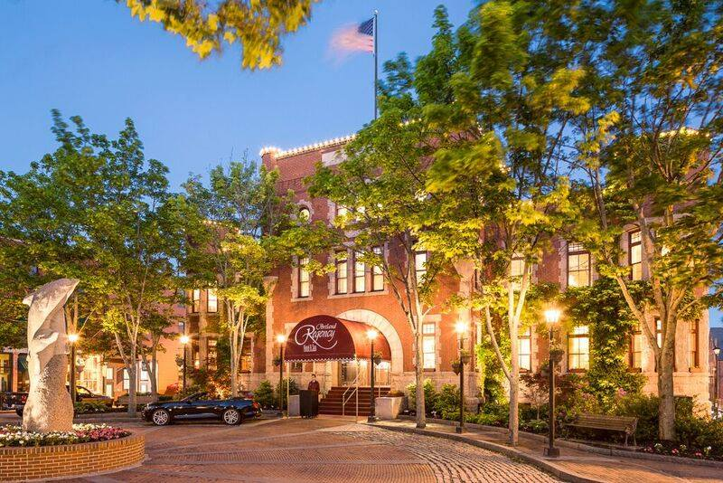

Make your Sleeping room reservation:
- SLEEPING ROOM RATE - Our special NIA rate is $229 per night plus 9% Maine State Sales Tax. Reservations must be guaranteed with a deposit of one night’s stay.

- PHONE RESERVATIONS – These can be made by calling (207) 774-4200 and reference Northeast Ice Association (NIA). Unfortunately, this hotel does not offer online booking options.

- CANCELLATION - Group rooms require 72-hours cancellation to avoid penalty.

- PARKING - Valet parking is available at $25.00 for overnight parking or $5.00.

RESERVATIONS CUTOFF DATE - We have a hotel cutoff date of Monday, September 5, 2023 or until or room block fills up. Please be sure to book your hotel room early! After this date (or if the room block is full), the special NIA rate may no longer be available.

